**CODE:-**

#include <iostream>

using namespace std;

class Students

{

protected:

char name[20];

int rollno;

public:

void getdata()

{

cout << "Enter name and roll number of student." << endl;

cin >> name >> rollno;

}

void display()

{

cout << "Name: " << name << endl

<< "Roll Number: " << rollno << endl;

}

};

class Arts : public Students

{

protected:

int history_marks;

int geography_marks;

public:

void getdata()

{

cout << "Enter the history and geography marks." << endl;

cin >> history_marks >> geography_marks;

}

void display()

{

cout << "History marks: " << history_marks << endl

<< "Geography Marks: " << geography_marks << endl;

}

};

class Medical : public Students

{

protected:

int anatomy_marks;

int pathology_marks;

public:

void getdata()

{

cout << "Enter the anatomy and pathology marks." << endl;

cin >> anatomy_marks >> pathology_marks;

}

void display()

{

cout << "Anatomy marks: " << anatomy_marks << endl

<< "Pathology marks: " << pathology_marks << endl;

}

};

class Engineering : public Students

{

protected:

int maths_marks;

public:

void getdata()

{

cout << "Enter the maths marks." << endl;

cin >> maths_marks;

}

void display()

{

cout << "Maths marks: " << maths_marks << endl;

}

};

class Mech : public Engineering

{

protected:

int thermo_marks;

public:

void getdata()

{

cout << "Enter the thermodynamic marks." << endl;

cin >> thermo_marks;

}

void display()

{

cout << "Thermodynamics marks: " << thermo_marks << endl;

}

};

class Elec : public Engineering

{

protected:

int machines_marks;

public:

void getdata()

{

cout << "Enter the machines marks." << endl;

cin >> machines_marks;

}

void display()

{

cout << "Machines marks: " << machines_marks << endl;

}

};

class Civil : public Engineering

{

protected:

int geology_marks;

public:

void getdata()

{

cout << "Enter the geology marks." << endl;

cin >> geology_marks;

}

void display()

{

cout << "Geology marks: " << geology_marks << endl;

}

};

int main()

{

Arts s1;

s1.Students::getdata();

s1.getdata();

s1.Students::display();

s1.display();

Medical s2;

s2.Students::getdata();

s2.getdata();

s2.Students::display();

s2.display();

Mech s3;

s3.Students::getdata();

s3.Engineering::getdata();

s3.getdata();

s3.Students::display();

s3.Engineering::display();

s3.display();

Elec s4;

s4.Students::getdata();

s4.Engineering::getdata();

s4.getdata();

s4.Students::display();

s4.Engineering::display();

s4.display();

Civil s5;

s5.Students::getdata();

s5.Engineering::getdata();

s5.getdata();

s5.Students::display();

s5.Engineering::display();

s5.display();

return 0;}

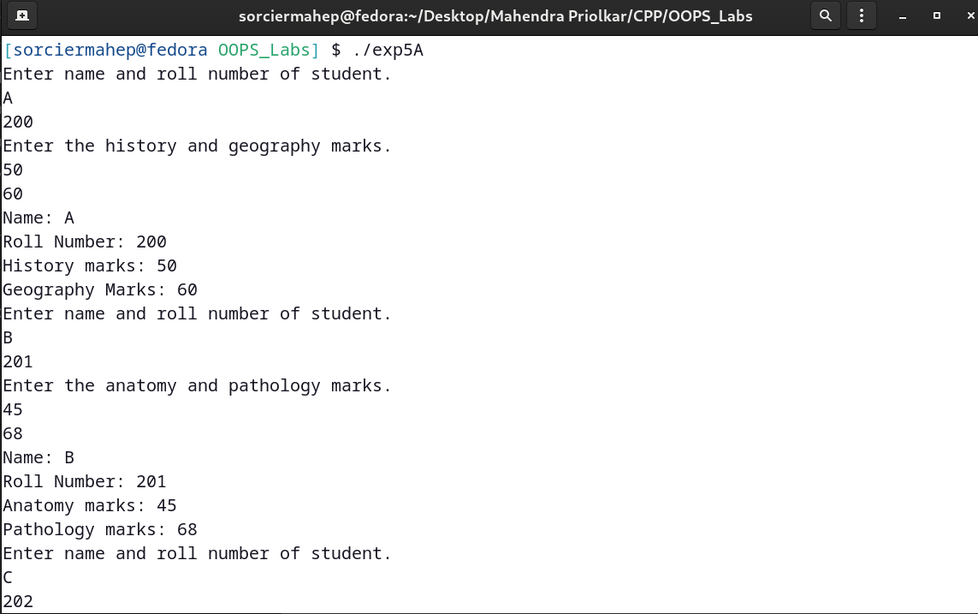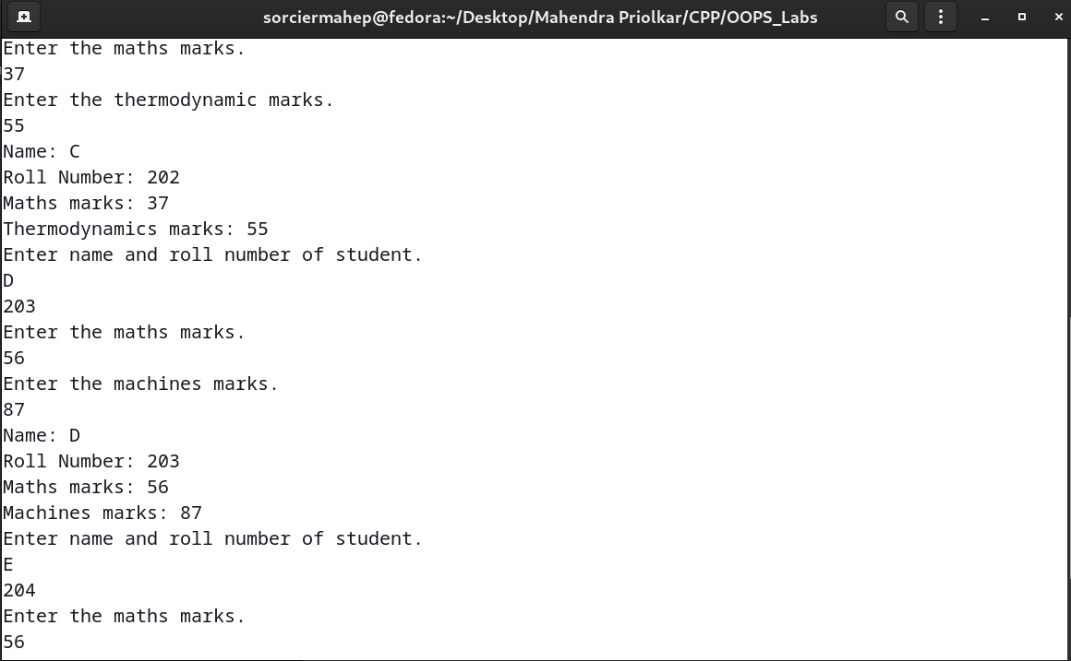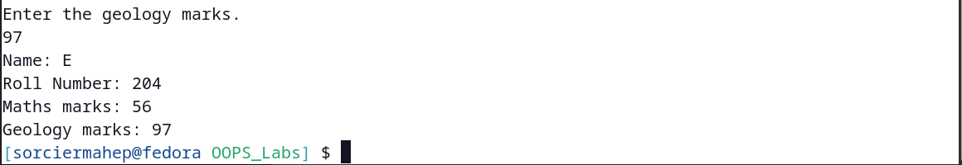**OUTPUT:-**

**CODE:-**

#include <iostream>

using namespace std;

class student

{

protected:

int rollno;

public:

void get_no(int a)

{

rollno = a;

}

void put_no()

{

cout << "Roll number : " << rollno << endl;

}

};

class test : virtual public student

{

protected:

float part1, part2;

public:

void get_m(float x, float y)

{

part1 = x;

part2 = y;

}

void put_m()

{

cout << "Marks obtained : " << endl

<< "Part 1 : " << part1 << endl

<< "Part2 : " << part2 << endl;

}

};

class sports : public virtual student

{

protected:

float score;

public:

void get_s(float s)

{

score = s;

}

void put_s()

{

cout << "Sports marks : " << score << endl;

}

};

class result : public test, public sports

{

float total;

public:

void display()

{

total = part1 + part2 + score;

put_no();

put_m();

put_s();

cout << "Total score : " << total << endl;

}

};

int main()

{

result s1;

s1.get_no(211105032);

s1.get_m(87.5, 91.5);

s1.get_s(7.0);

s1.display();

return 0;

}

**OUTPUT:-**

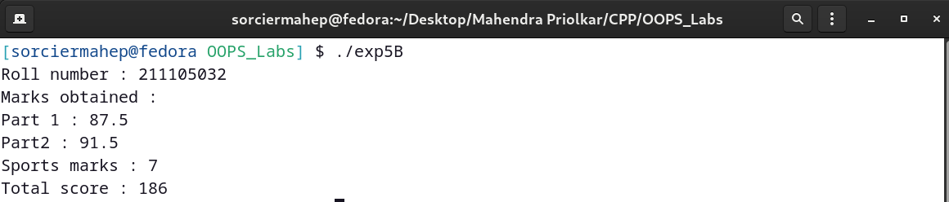

**CODE:-**

#include <iostream>

using namespace std;

class alpha

{

int x;

public:

alpha(int i = 0)

{

x = i;

cout << "alpha initialized." << endl;

}

void show_x()

{

cout << "x = " << x << endl;

}

};

class beta

{

float y;

public:

beta(float j = 0.0f)

{

y = j;

cout << "beta initialized." << endl;

}

void show_y()

{

cout << "y = " << y << endl;

}

};

class gamma : public beta, public alpha // Beta is initialized first

{

int m, n;

public:

gamma(int a, int b, float c, int d) : alpha(d), beta(c) // Initialization List

{

m = a;

n = b;

cout << "gamma initialized." << endl;

}

void show_mn()

{

cout << "m = " << m << endl

<< "n = " << n << endl;

}

};

int main()

{

gamma g(5, 10, 3.75, 7);

g.show_x();

g.show_y();

g.show_mn();

return 0;

}

**OUTPUT:-**

